1.封面
标题：Kao Megu Calm Silent Steam Eye Mask’s Marketing Communication Strategy
组号：Group 2

2.目录
Opening Situational analysis Marketing Mix considerations Conclusions / Closing to your presentation References

3.opening封面

4. task division
Songzheng Yu Junkai Bao Yefeng Fu Yutian Zhang
24124416 24124337 24124328 24124416
document drafting document drafting video recording video recording
PPT Design PPT Design
video recording video recording

5. Purpose
Problem: Consumers suffer from noise-related sleeping problems and eye strain, while traditional eye masks often have only a single function and can be relatively expensive.

Solution: We provide a cost-effective hybrid product that combines noise reduction and steam eye care to improve sleep quality and relieve eye fatigue.
添加图片
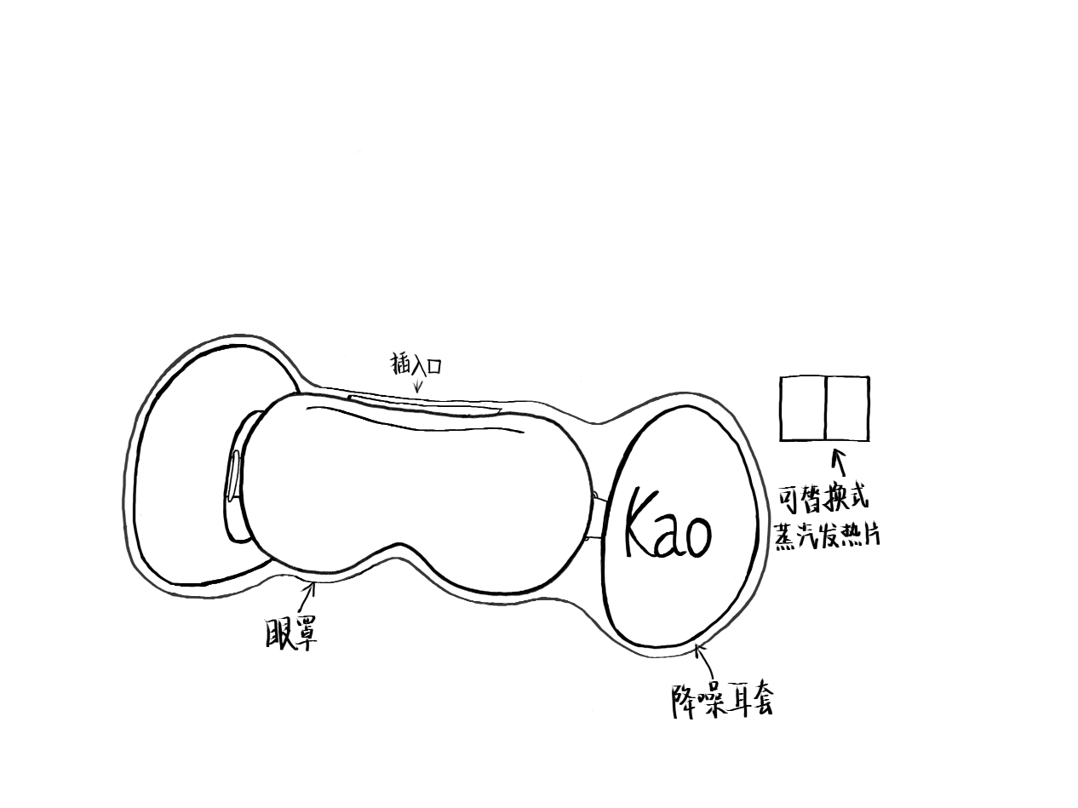
6. Situational analysis封面

7. Target market analysis（做成表格）

Geographic Segmentation
Location：√Urban vs Rural
Economic level:√developed vs developing

Demographic Segmentation
Age: √young adults/teenager vs middle-aged/elderly
Income: Middle–high vs √Middle–low

Psychographic Segmentation
Emphasis on quality of life: √high Vs low
Values orientation: Hedonistic vs √practical

Behavioral Segmentation
Price sensitivity: √high vs low
Response to Promotion: √High vs Low

8. Target market analysis

target market segment：practical and price-sensitive young adults and teenagers in urban areas of developing regions, with middle–low incomes, a strong focus on quality of life, and intense response to promotion

Target consumer groups： young students and urban young employees.（此处应该有两类人群的配图）

9. Reasons for Target
High Demand
Key Market Evidence
- 53% of people experience sleep problems (IBISWorld, 2025)
- Sleep issues are more severe among young people (Hershner & Chervin, 2014)
- 32.1% of sleep problems are caused by noise
- 97.6% of Australians experience eye fatigue
Implication
- Strong overlap between sleep problems and eye strain
- Our target market directly faces these issues
- Strong need for an integrated solution
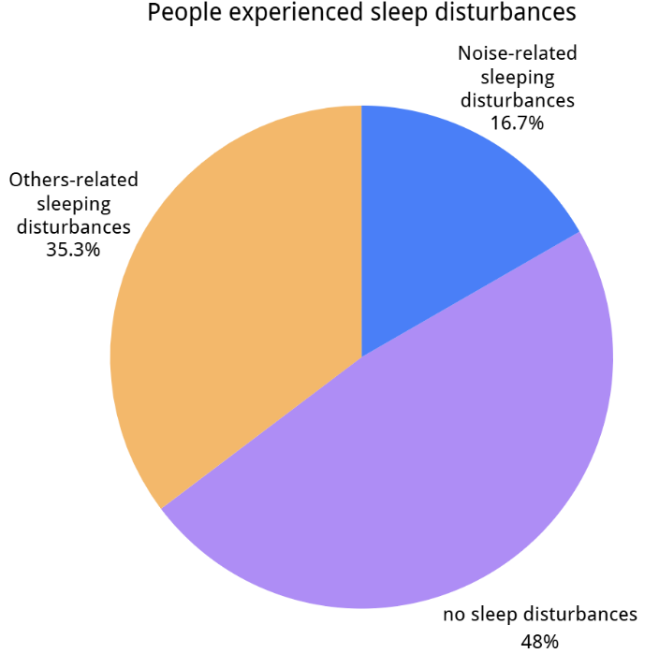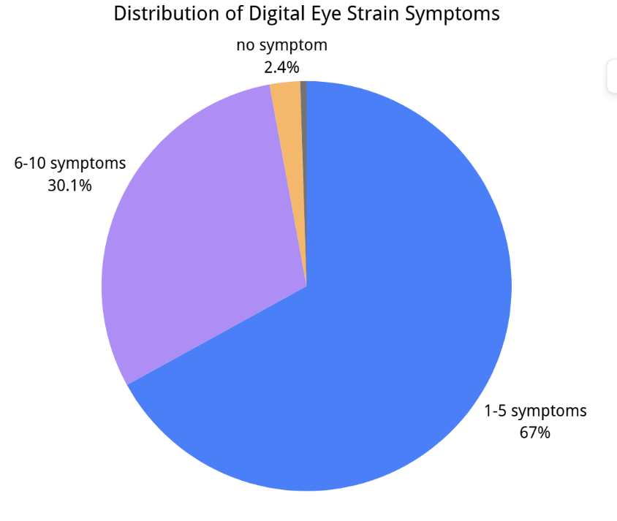
(Bin Maneea et al., 2024)

10. Reasons for Target

Target Consumer Characteristics
- Millennials & Gen Z have lower income levels → more price-sensitive and value-driven (Deloitte, 2023; OECD, 2025)
- Students and white-collar workers are concentrated in urban areas (OECD, 2020)
- These groups place strong emphasis on quality of life (Deloitte, 2023)
Product Fit
- High cost-effectiveness through pricing and refill design
- Improves sleep quality and relieves eye strain
- Enhances overall quality of life

11.SWOT封面

12. Strength
high brand awareness and reputation
A multifunctional product, simultaneously addressing eye strain and noise disturbance.
Reusable mask with refill system provides stronger cost efficiency

13. Weakness
a new product concept, requiring consumer understanding and acceptance.
long-term revenue needs refill repurchase, requiring high customer loyalty.
Higher initial price than basic sleep masks may reduce impulse purchases.

14. Opportunities
Mature current technology, strong research and production capabilities
Developed sales and promotional system
The sleep eye mask market in Australia is expected to continue growing.
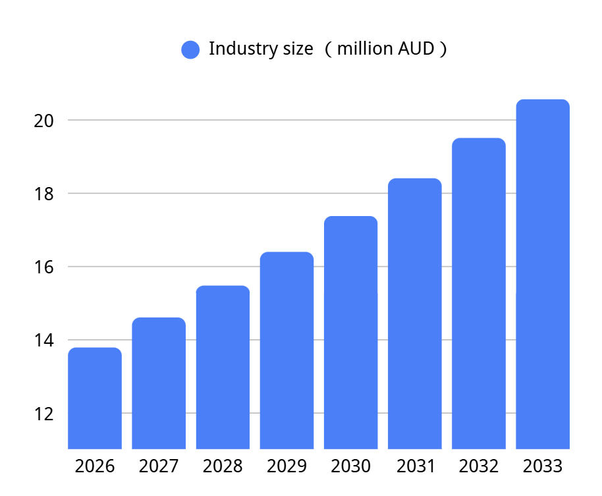
(Deep Market Insights, 2024)

15. Threats
Kao has limited development in the Australian market
The steam eye mask market in Australia remains small.
Economic pressure and inflation may reduce spending on non-essential lifestyle products.

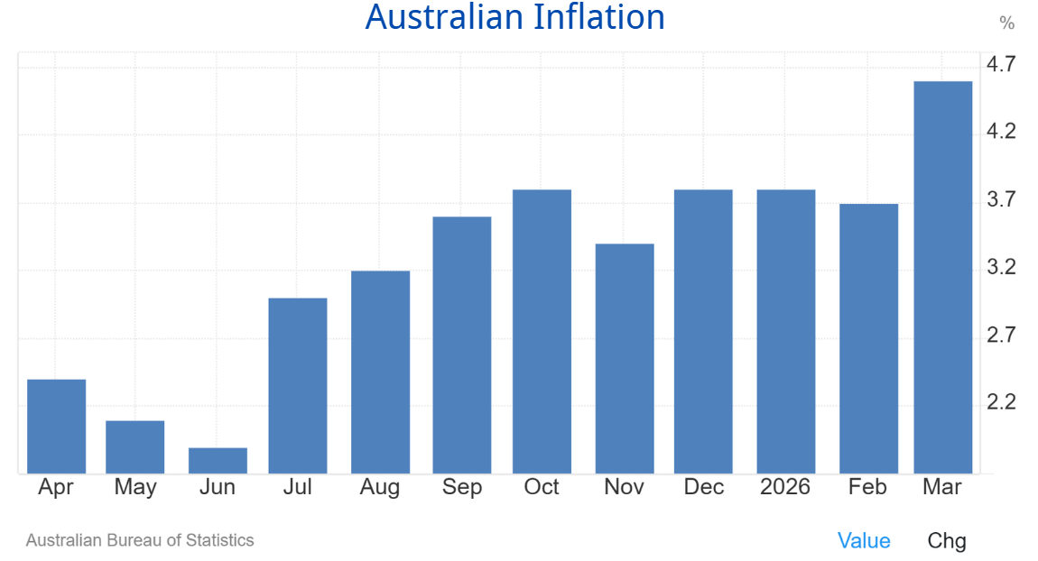

(Trading Economics, n.d.)

16
Smart goals
The objective is to achieve brand awareness among approximately 10% of the defined target customer segment in the first year.

Our goal of achieving 10% brand awareness in the first year is achievable but moderately challenging, supported by strong brand equity, R&D capability, and rising demand in Australia, yet constrained by product novelty, price sensitivity, and the relatively small market size.

17. Marketing Mix considerations封面

18.product封面

19.

（用图标）
Core Product
Improve sleep quality by blocking noise and relieving eye strain.

EXPECTED PRODUCT:
Noise-reducing ear covers reduce external noise.
Steam inserts generate heat to provide eye care
Soft and lightweight materials enhance comfort.
Reusable eye mask with replaceable steam inserts

3- AUGMENTED PRODUCT:
Free delivery service
QR code to view the instructions for use
Unconditional return and exchange for damaged one within two months.

4- POTENTIAL PRODUCT:

Personalized steam inserts (relaxation, aroma, cooling)
Points-based system and membership discount policies.

20. product classification
Shopping products
- Suitability
Consumers evaluate whether the product fits their specific needs
• sleep improvement
• eye strain relief
• noise reduction

- Quality
Consumers compare product performance and materials
• high durability from reusable design

3. Price
Consumers are sensitive to price
Cost-effective in the long term due to the refill system.

21.position(这个也得改)
Product Positioning
A cost-effective sleep improvement product that reduces noise disturbance and relieves eye strain.
Brand Positioning
A trusted and supportive brand that helps young consumers improve their quality of life.
Retail Positioning
A convenient and affordable product offering easy access and attractive promotional discounts.

22.price封面

23. product analysis
Product characteristics: high substitutability and non-essential nature
Target consumer groups (young students and urban young employees): high price sensitivity and responsiveness to promotions.
Competitor products: noise-reducing eye masks and standard eye masks.

24
price method: Competition-Based Pricing

Research suggests that when products are substitutable, price competition becomes “inevitable and critical” in pricing decisions. (Zhao et al., 2014)
Pricing:
Mask positioned in the lower-to-mid range of noise-reducing eye masks (AU$30–50);
steam inserts priced below market average for steam eye masks (AU$24–40 per box).

25. Psychological pricing strategy (四个框)
Referencing pricing
The Dream Essentials Natura Organic Sleep Mask——AU$39.95
(Sleep and Sound, n.d.)
Kao MegRhythm Gentle Steam Eye Mask 12PCS Rose Scented Relaxing Stress Relief — AU$24.60
(La Cosmetique, n.d.)

Product Bundle Pricing
Hybrid mask + first steam refill pack

Odd even pricing
Pricing ends with a “9” for added appeal

Differential Pricing
Steam inserts: 2nd box −20%, 3rd box −40%.

26.price
Base prices
- Noise-reducing sleep mask: AU$35.90
- Steam refill pack: AU$19.90
Discount benchmark: 20% off
Bundle / promotional pricing:
- Sleep mask + 1 steam refill pack: AU$49.90
- Two-box steam refill bundle：35.83
- Three-box steam refill bundle: 47.76
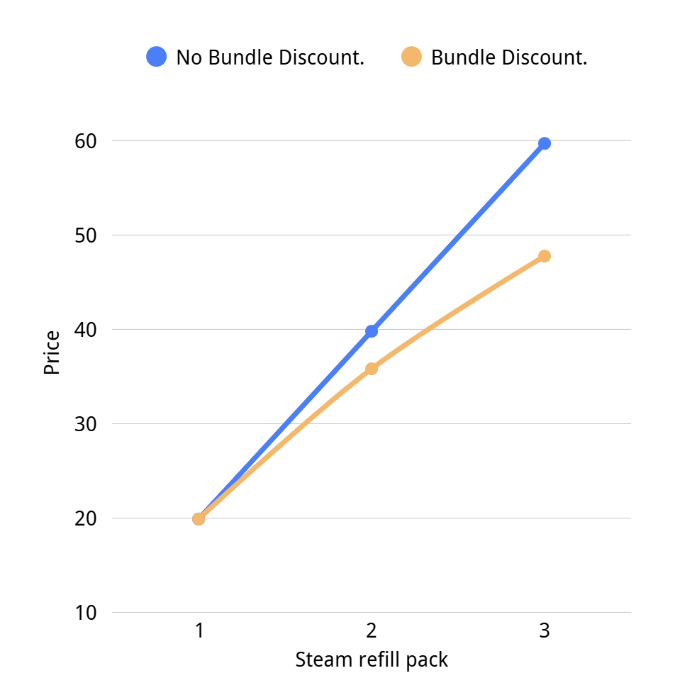
Member / loyalty pricing:
- :Members / low-tier points users: 20% off
- High-tier points users: 30% off

27. PLC
Introduction Stage
Penetration pricing
Our actions
- Early-bird offer
First-purchase discount

Growth Stage
Differential pricing
Our actions:
- Bundle pricing
- Student pricing
- Official-store pricing

Maturity Stage
Promotional pricing
Our actions:
- Loyalty points and Member-only discounts
- Limited-time discounts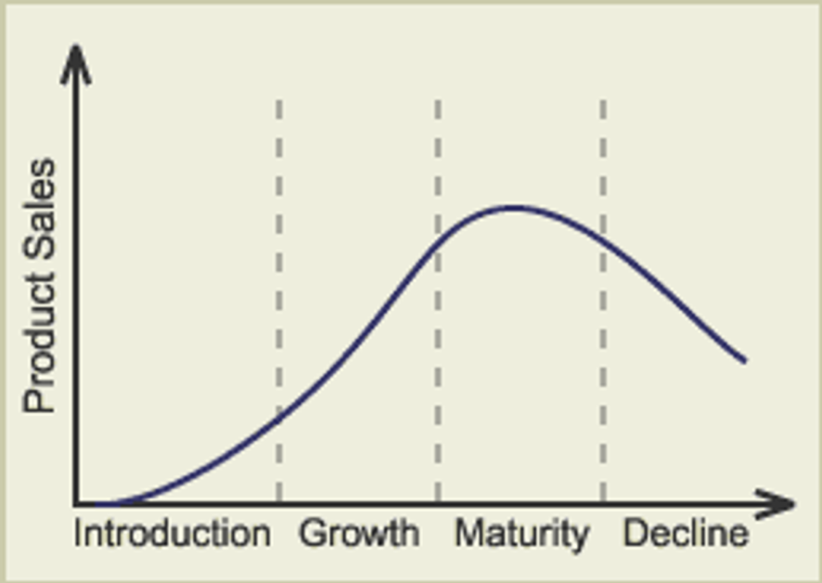

28.promotion封面

29. Advertising
advertise on social media and video platforms.
For example, influencers can introduce our product in their content, while story-based short videos show young people experiencing stress, eye fatigue, and poor sleep to create emotional resonance with consumers.
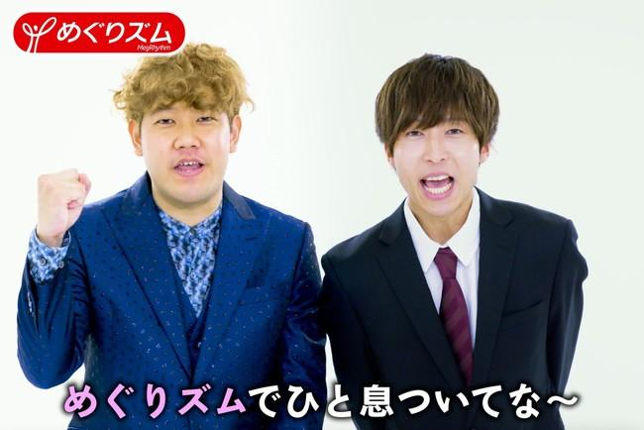

30. Public Relations
Participate in social welfare activities
For example, conduct free sleep and eye-care workshops for the public with free product samples to participants, and share the events on social media platforms
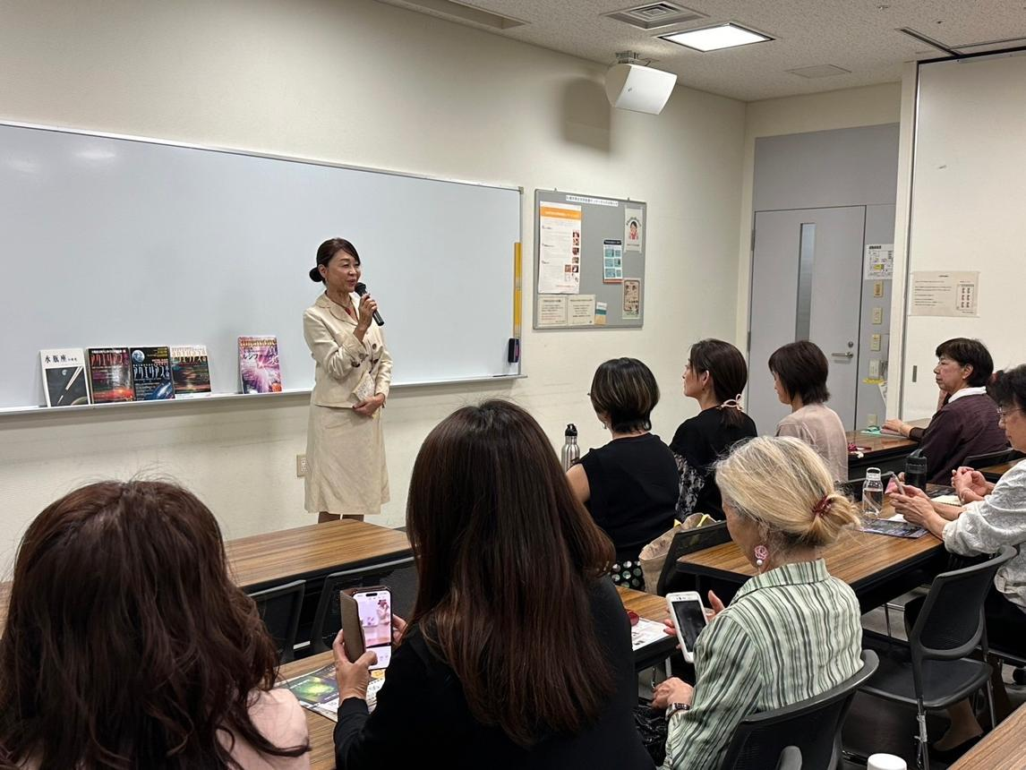

31. Sales Promotions
offer attractive discounts.
For example, discounts can be offered to specific groups such as first-time buyers and students, along with seasonal limited-time promotional prices.

32. Personal Selling
face-to-face promotion
For example, product exhibitions can be held on university campuses, where staff engage in one-on-one promotion with students, introduce the product, and offer discounted prices.

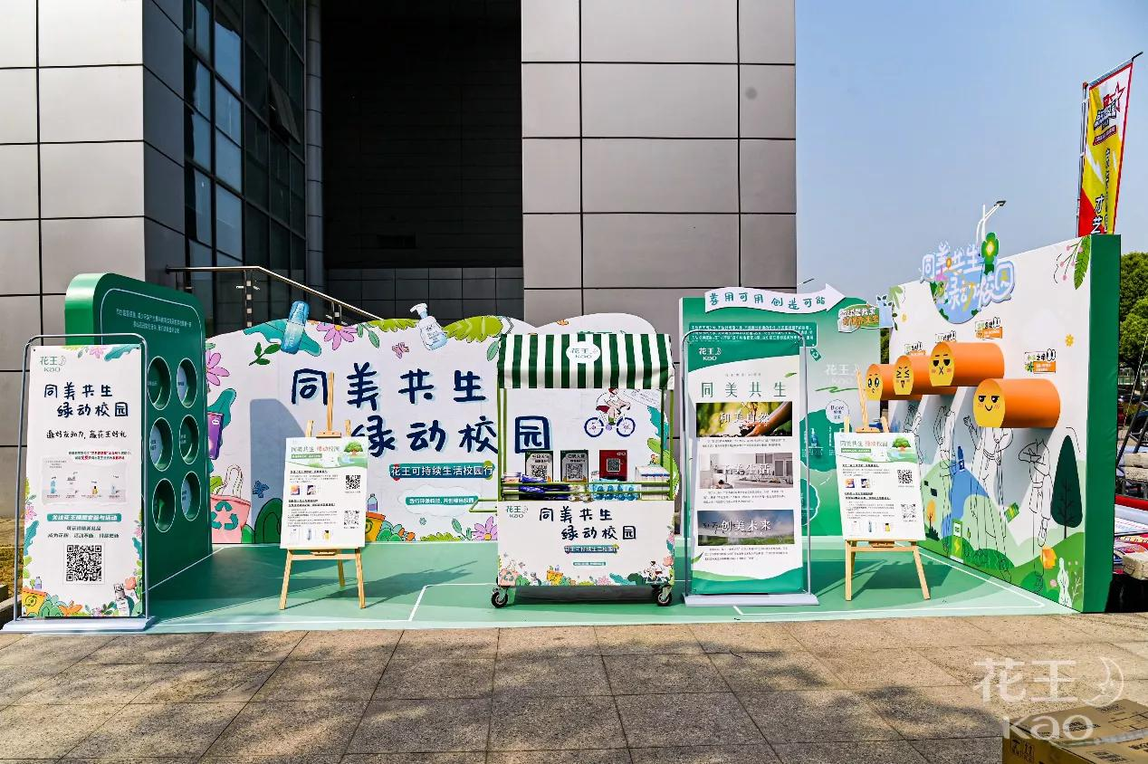

33.place按照之前图片的格式做。
Channel 1: Producer → Consumer
Flow:
Official website + flagship stores on online shopping platforms. (Amazon)

34
Channel 2: Producer → Retailer → Consumer
Flow:
Online retailer: Woolworths Online / Coles Online.
Offline retailer: Woolworths Supermarkets / Coles

35
Channel 3: Producer → Wholesaler → Retailer → Consumer
Flow:
Wholesaler: Metcash.
Retailers: IGA / Foodland / Friendly Grocer.

34.conclusion
In conclusion, through clear market targeting, competitive pricing, multifunctional product design, and integrated promotional strategies, Kao Megu Calm Silent Steam Eye Mask has strong potential in the Australian market.

By addressing both sleep problems and eye strain in a cost-effective way, the product is well positioned to meet the growing needs of young consumers and achieve promising market prospects.

Reference
OECD. (2025). Youth employment and social policies.
https://www.oecd.org/en/topics/youth-employment-and-social-policies.html

Deloitte. (2023).
Global Gen Z and Millennial Survey 2023. Deloitte Insights.
https://www.deloitte.com/global/en/issues/work/content/genz-millennial-survey.html

Hershner, S., & Chervin, R. (2014).
Causes and consequences of sleepiness among college students.
Nature and Science of Sleep, 6, 73–84.
https://doi.org/10.2147/NSS.S62907

OECD. (2020). Rural well-being: Geography of opportunities.
https://www.oecd.org/regional/rural-well-being.htm

Bin Maneea, M. W., Alamawi, H. O., Almuqbil, A., Abukhlaled, J. K., Alsuwailem, G., Alabdulminaim, J., Aladawi, A. M. M., & Alshangiti, A. Y. (2024). Digital eye straining: Exploring its prevalence, associated factors, and effects on quality of life. Cureus. https://doi.org/10.7759/cureus.59442

IBISWorld. (2025). Sleep Disorder Clinics in the US (NAICS 621399). IBISWorld Industry Report. Available at: https://www.ibisworld.com (Accessed: 14 April 2026).

Delaney, L. J., Currie, M. J., Huang, H. C., Lopez, V., & Litton, E. (2018). “They can rest at home”: An. observational study of patients’ quality of sleep in an Australian hospital. BMC Health Services Research, 18, 524. https://doi.org/10.1186/s12913-018-3320-z

Zhao, J., Wei, J., & Li, Y. (2014). Pricing decisions for substitutable products in a two-echelon supply chain with firms’ different channel powers. International Journal of Production Economics, 153, 243–252. https://doi.org/10.1016/j.ijpe.2014.03.005

La Cosmetique. (n.d.). Kao MegRhythm steam mask (rose fragrance) 12pcs. https://lacosmetique.com.au/products/megrhythm-steam-mask-rose-fragrance-12pcs

Amcal Pharmacy. (n.d.). Dreamlight Ease Lite contoured sleep mask. https://www.amcal.com.au/shop/product/MMC-O100024378/dreamlight-ease-lite-sleep-eye-mask/

Sleep and Sound. (n.d.). Dream Essentials Natura Organic Sleep Mask. Sleep and Sound.
https://sleepandsound.com.au/shop/sleep-solutions/sleep-masks/total-light-blocking-sleep-masks/dream-essentials-natura-organic-sleep-mask/

Deep Market Insights. (2024). Australia sleep mask market size & forecast (2025–2033). https://deepmarketinsights.com/vista/insights/sleep-mask-market/australia

Trading Economics. (2026). Australia inflation rate (CPI). https://tradingeconomics.com/australia/inflation-cpi

